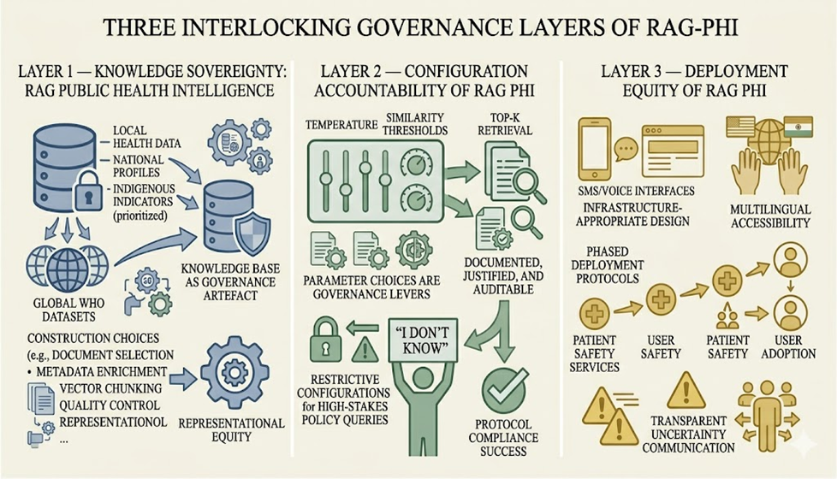

Figure 1: RAG-PHI Conceptual Framework (visualized by author using AI-assisted image generation tool, saved as Tiff. File)
Figure 1 Alt Text: A conceptual diagram of the RAG-PHI governance framework structured as three nested layers. The innermost layer represents Knowledge-Base Sovereignty, the intermediate layer represents Configuration Accountability, and the outermost layer represents Deployment Equity. Directional arrows trace the influence pathway from independent governance pillars through mediating process variables toward dependent outcomes, specifically hallucination reduction and factual accuracy.
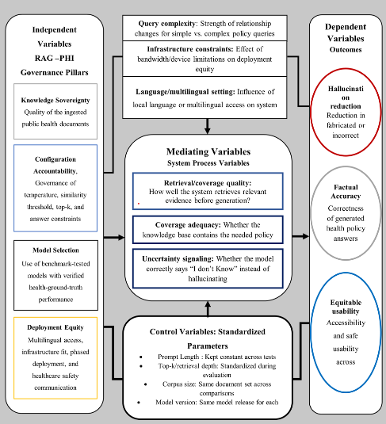
Figure 2 Proposed Conceptual Theoretical framework using RAG PHI, System Config and Parameters of RAG PHI
Figure 2 Alt Text: Theoretical framework diagram mapping RAG-PHI construct types such as Independent, Mediating, Moderating, Dependent, and Control variables which are interconnected boxes with directional arrows showing hypothesized causal pathways from knowledge sovereignty with configuration accountability accounting to health policy intelligence outcomes.
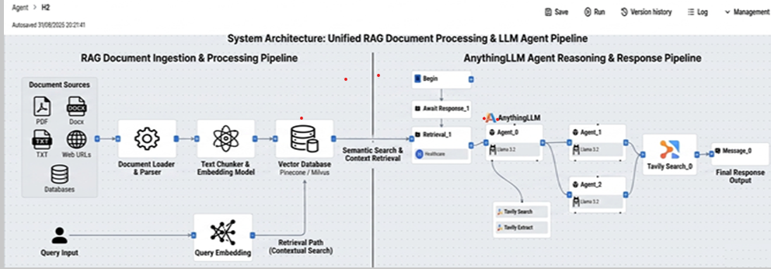

Figure 3: Unified System Architecture depicting RAG Flow and AnythingLLM’s agent pipelines, showing document processing, vector-based retrieval, and response generation. Parameter positions for Configuration A and Configuration B are shown at respective retrieval and generation stages. (Visualized by author using AI-assisted image generation tool, saved as TIFF file).
Figure 3 Alt Text: A flowchart represents two parallel retrieval-augmented generation pipelines side by side. The left pipeline represents AnythingLLM’s, which employs Chroma DB for vector retrieval. The right pipeline represents RAG Flow, which uses FAISS-based hybrid retrieval. Both pipelines has stages: document ingestion, text chunking, embedding generation, vector search, and language model response generation. The positions at which Configuration A and Configuration B parameters take effect is labelled at the retrieval and generation stages of each pipeline.

